|  |  |
| --- | --- |
| Acceptance Tests    1.Acceptance Test Scope (In Scope – Out of Scope) | |
| Acceptance Test- In Scope | **Acceptance Test - Out of Scope** |
| In Scope TESTED features:   * Gameplay table screen should open up once joined room * The rummy-o game has to follow the rules described in the rummy-o section. * The rummy-o game is to be hoisted as a web application and service remote players | Out of Scope List features that are not tested:   * Deletion of Tiles * Mobile testing |

|  |
| --- |
| **2. Acceptance Test Assumptions** |
| **Acceptance Test Assumptions** |
| * Test environment: The test cases are conducted by the group members on their respective laptops * Test documentation: All acceptance test cases are documented within GitHub Project folder * Error reporting: Errors, failures and other flaws are reported using Jest which was taught in the final Lab. |

|  |  |  |  |
| --- | --- | --- | --- |
| **3. Acceptance Test Risks** | | | |
| Description | Probability  High|Med|Low | Impact  High|Med|Low | Mitigation |
| In experienced testers (just learned in the last lab) | Med | Med | Learned a few testing procedures as taught in the final lab. |
| Incomplete-test environment (no experience) | High | Med | Resource planning at least a month prior to submission |
| Acceptance-test failure | Low | High | Project development completed before commencing acceptance test. |

|  |  |
| --- | --- |
| 4. Acceptance Tests Criteria | |
| **ID** | **Criteria** |
| AT-01 | The development of the Rummy-O game is successfully completed |
| AT-02 | Unit and Integration tests are completed |
| AT-03 | No major defects are detected |
| AT-04 | Acceptance test plan is available |
| AT-05 | The test environment (hardware, software (Jest, Windows, Linux)) is on |
| AT-06 | All business requirements are tested. |
| AT-07 | All encountered bugs must be fixed |

|  |  |  |  |  |  |
| --- | --- | --- | --- | --- | --- |
| 5. Acceptance Test Results | | |  | |  |
| **Test Cases** | **Pass/Fail** | **Tested By** | | **Date Tested** | |
| User LogIn / SignUp | Fail | Esam Uddin | | 03/22/2020 | |
| Room Session | Pass | Mihir Patel | | 03/24/2020 | |
| Board Screen | Pass | Fazal Rahman | | 03/27/2020 | |
| Multiplayer Connection (4-players) | Pass | Fazal Rahman | | 03/29/2020 | |
| Tile Dragging and Dropping | Pass | Ashwin Sudarshan | | 04/03/2020 | |
| Time intervals between turns | Fail | Esam Uddin | | 04/02/2020 | |
| Business Requirements are met | Pass | Ashwin Sudharshan | | 04/02/2020 | |

**Unit Tests**

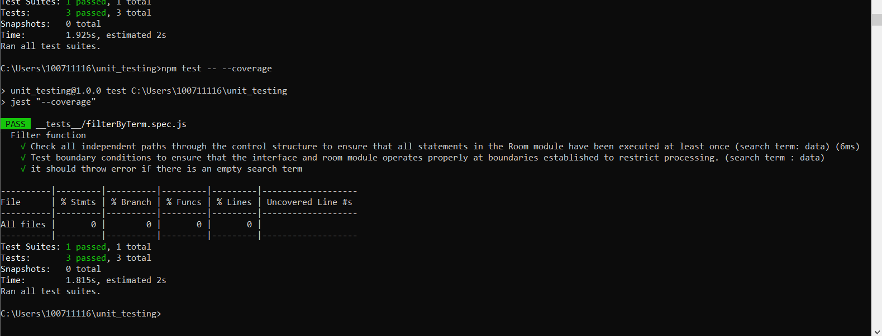 **All passed unit tests:**

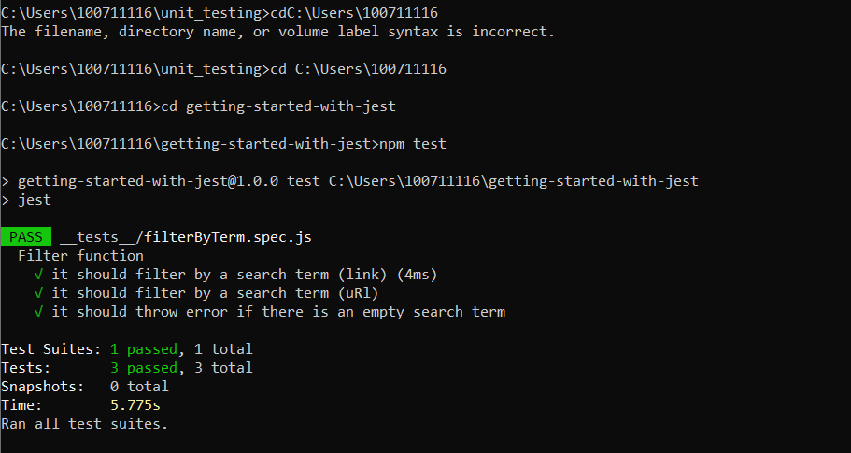

**Continuous Integration Test:**

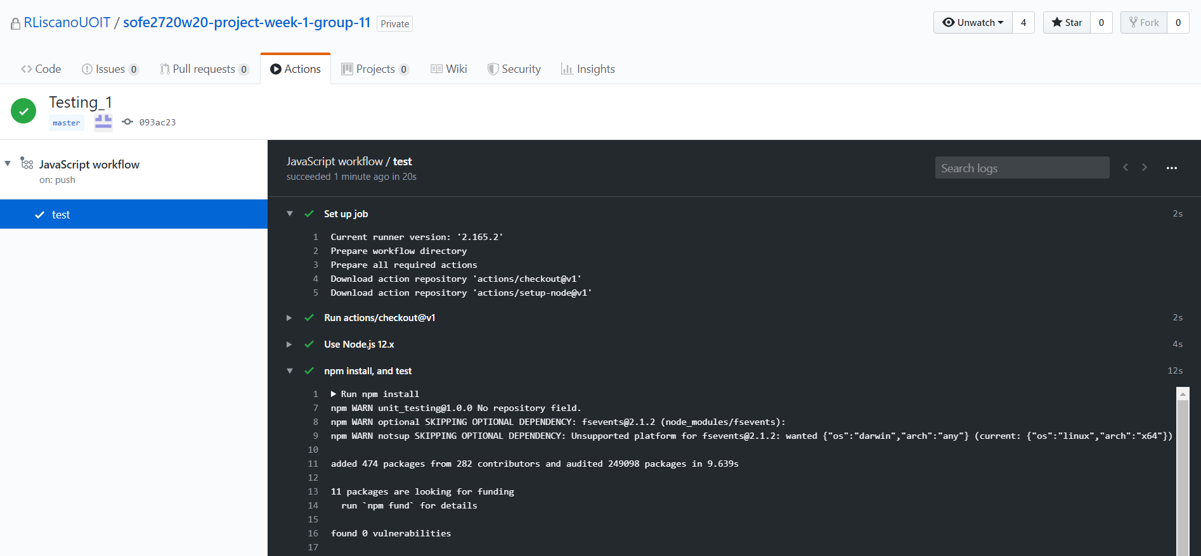

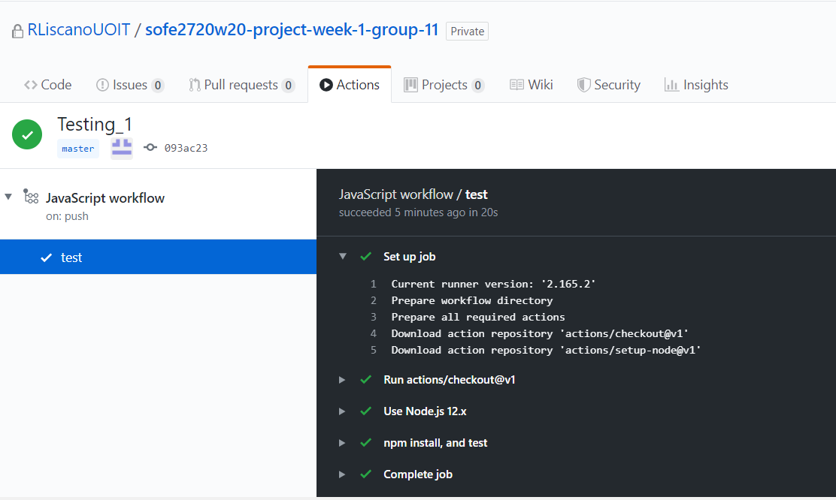

Continuous integration helped us build on the following core principles:

* code and configuration stayed under version control
* everything was automatically testable
* if the test broke then the bug was fixed

In conclusion, all tests passed successfully.